1) Write a select command that produces the order number, amount, and date fir all rows in the Orders table.

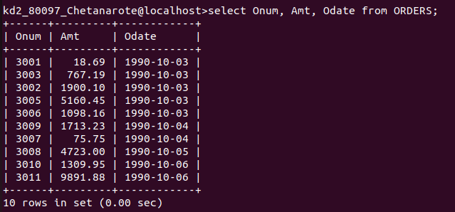

2) Write a query that produces all rows from the Customers table for which the salesperson's number is 1001.

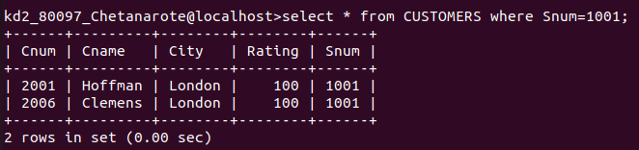

3) Write a query that displays the Salespeople table with the columns in the following order: City,Sname,Snum,Comm

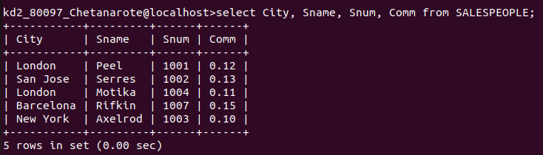

4) Write a select command that produces the rating followed by the name of each Customer in San Jose

